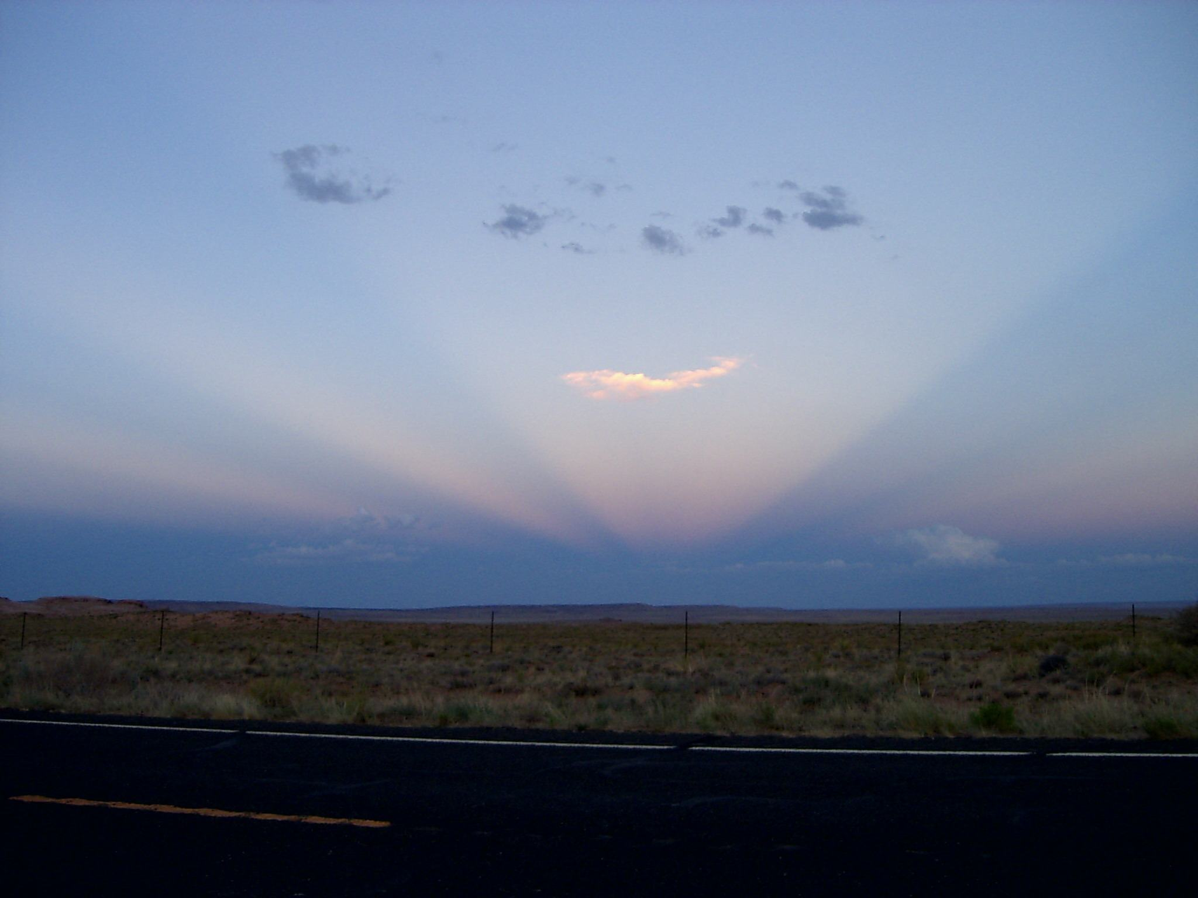
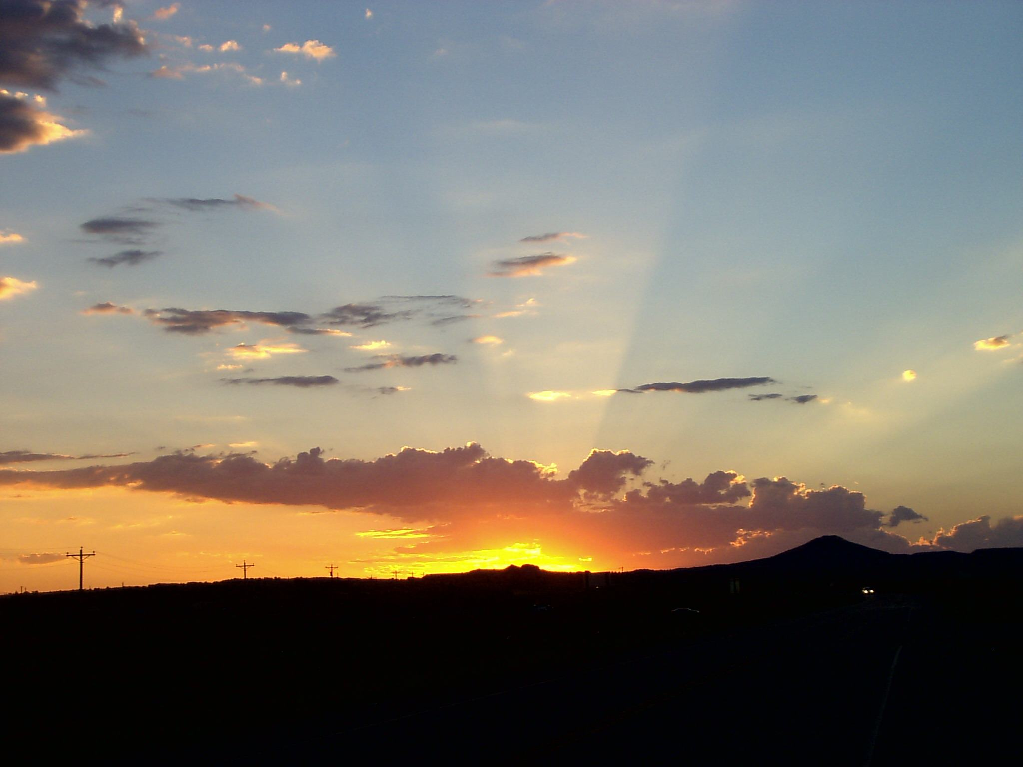
near Tuba City / Arizona; United States Highway 160
Friday July 13, 2007, ca. 8:00 h p.m.
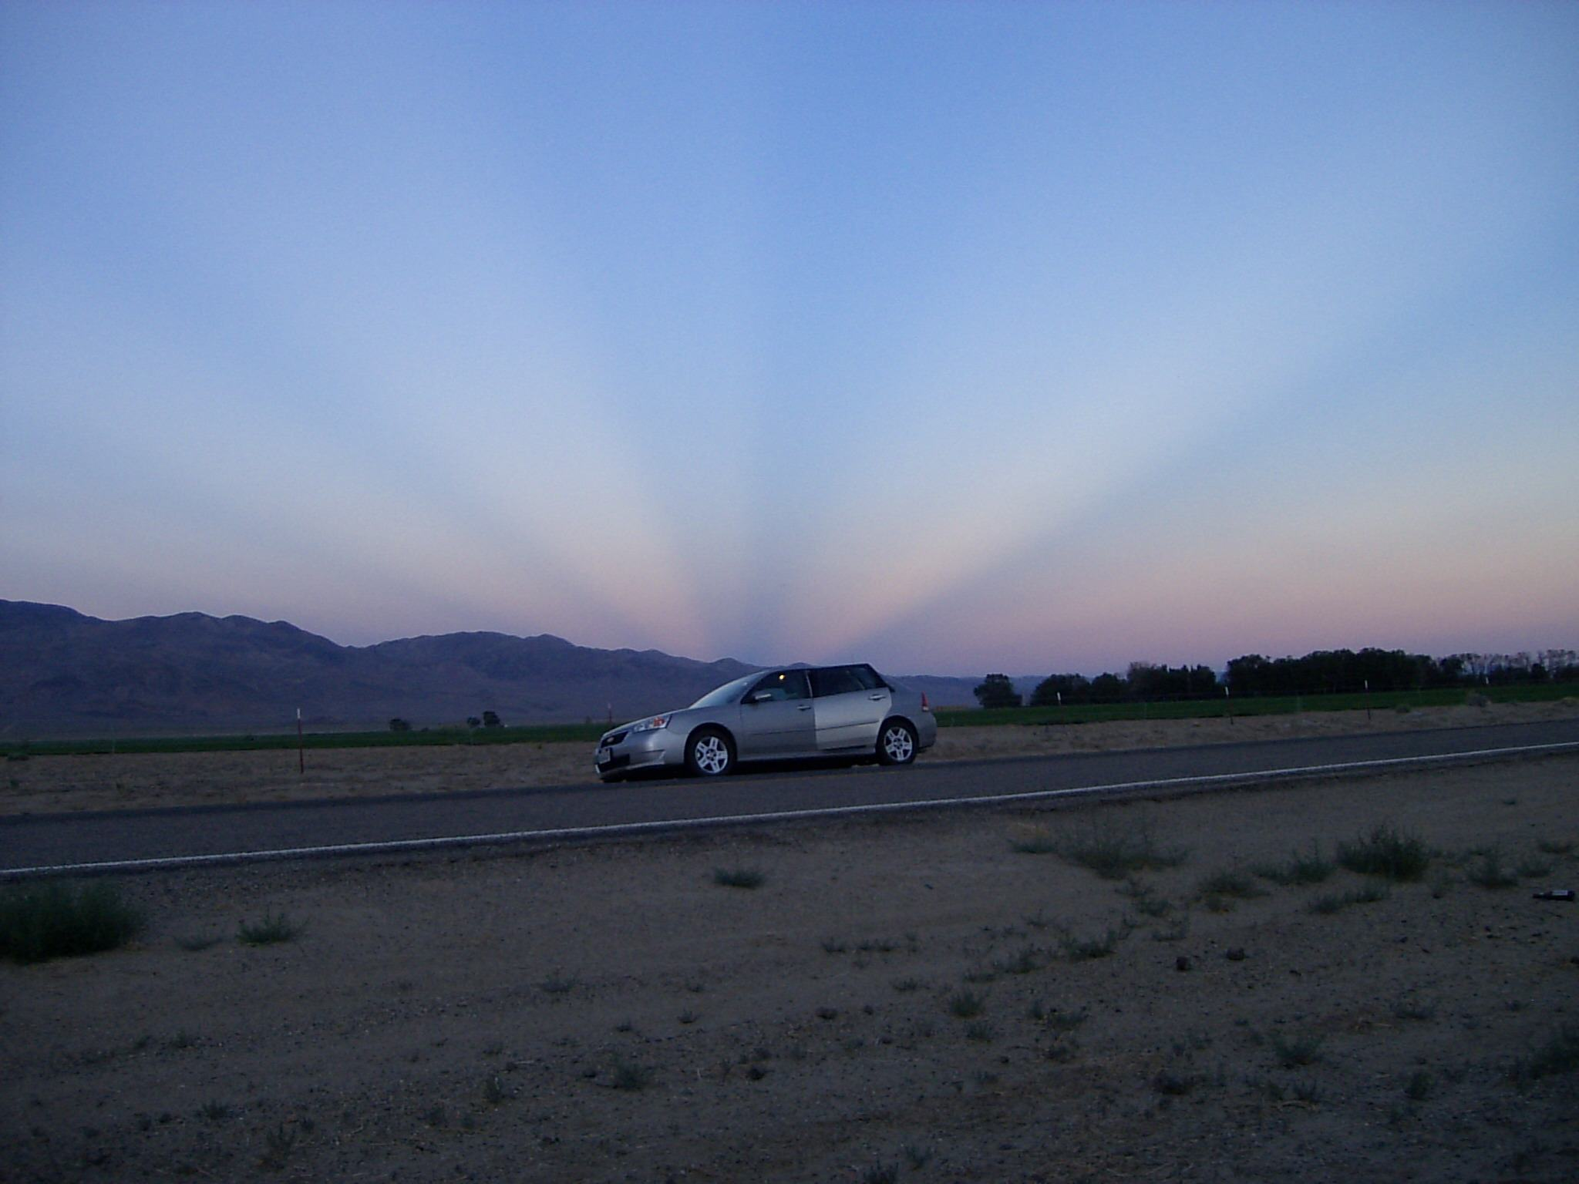
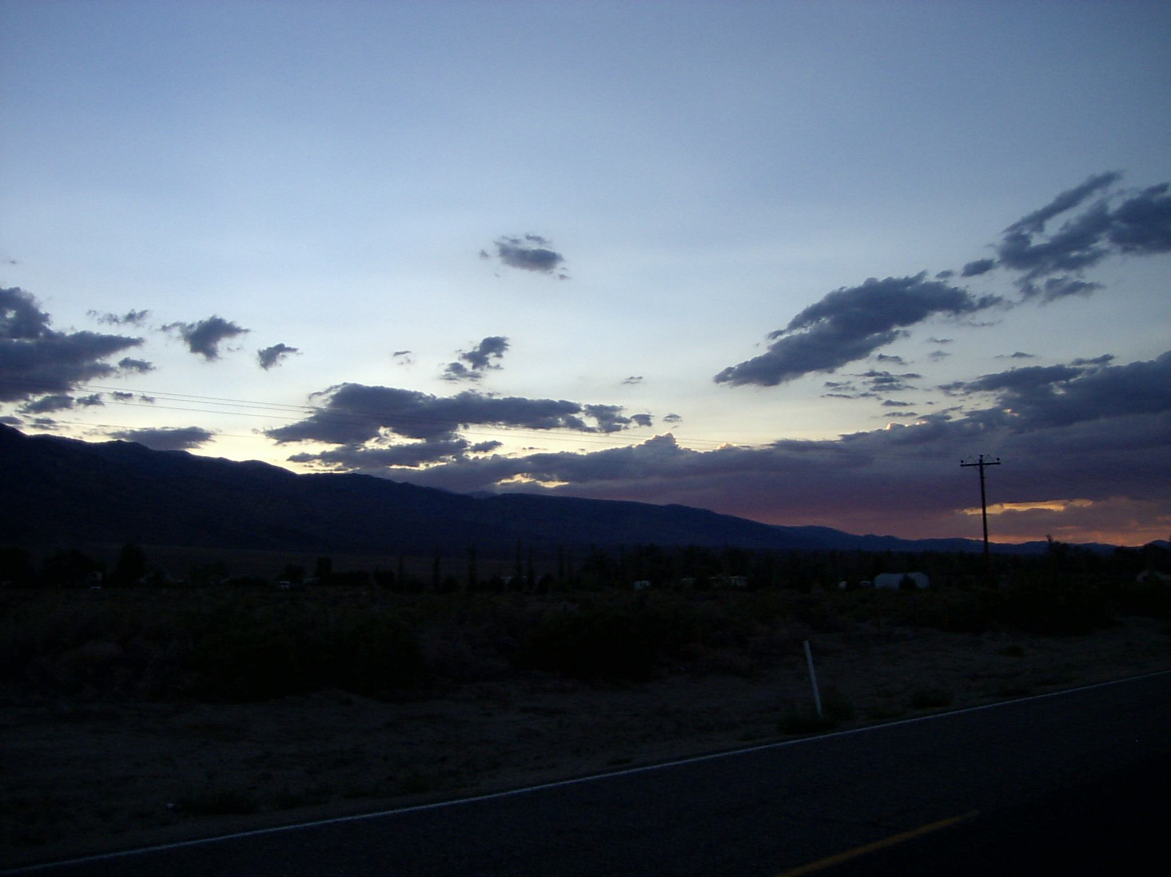
near Oasis / California; Cal. State Highway 168
Tuesday, July 17, 2007; ca. 8:00 h p.m.

